Vision Aided Navigation - Exercise 1 Report
Nir Ellor Waizner, Ayala Houri

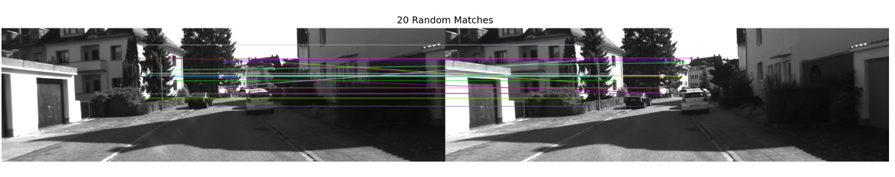
1.3. We matched descriptors using BFMatcher with Hamming distance.
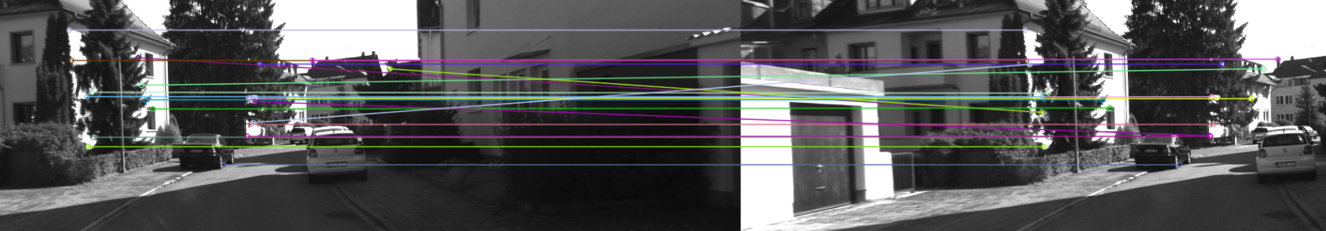
For better visualisation:

We can observe that some of the matches are incorrect. To improve the matching quality and remove ambiguous matches, we apply the ratio test in section 1.4.

1.4. In this section, we applied Lowe’s ratio test to filter out unreliable matches.
For each descriptor, we retrieved the two nearest neighbors using KNN matching.
A match was accepted only if the distance of the best match was significantly smaller than the second-best match, i.e., if the ratio between them was below a chosen threshold (we used a ratio value of 0.75).
Formally, we applied the condition: best/second < ratio, which is equivalent to m.distance < 0.75 * n.distance.
While the literature (e.g., Wikipedia) often uses a threshold around 0.8, we chose a stricter value of 0.75 to be more selective and reduce ambiguous matches.This ensures that the best match is distinct and not ambiguous compared to other candidates.
As a result, ambiguous matches are rejected, improving the overall reliability and quality of the matching.

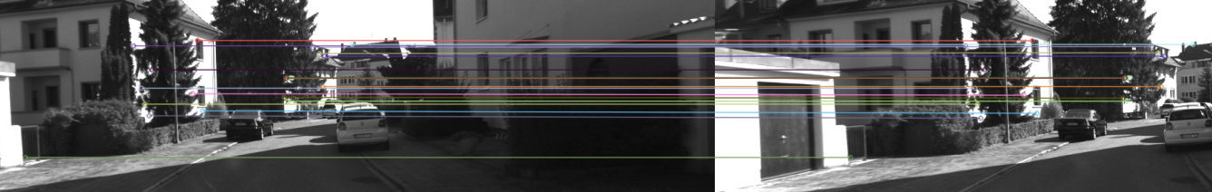
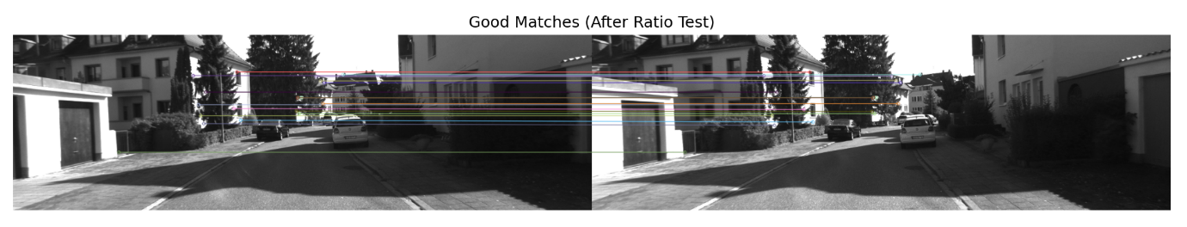
Upon inspecting the matching results, we observed that some correspondences are not perfectly aligned. Although they fall within the same general area, they do not match the exact corresponding point, indicating residual ambiguity.
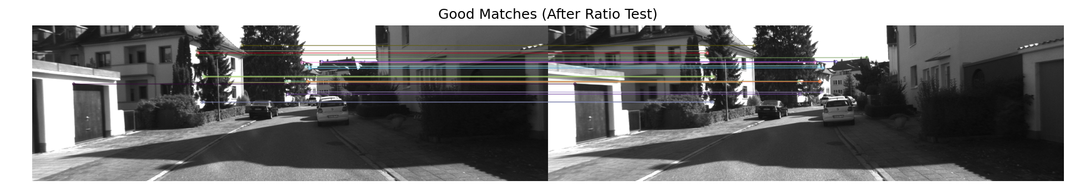
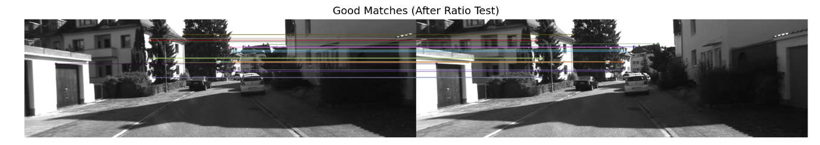
To address this, we further tightened the ratio threshold to make the filtering more restrictive.

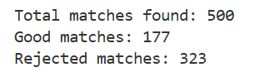
It can be observed that the results have improved. So the chosen ratio is: 0.6.
How many matches were discarded?

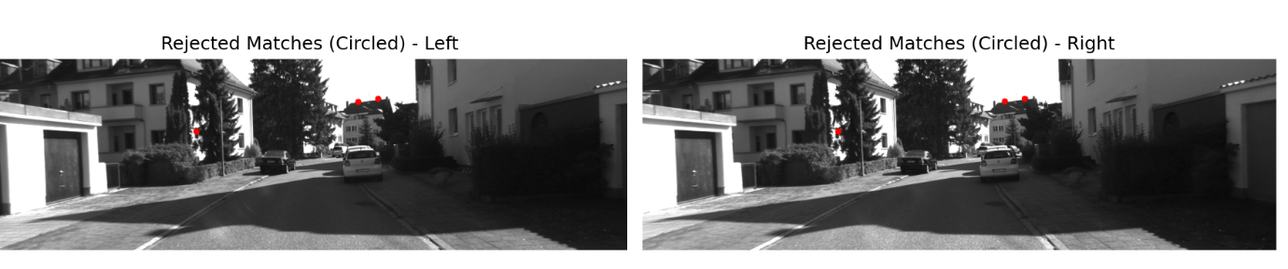
We now present a correct match that was rejected by the significance (ratio) test.
It can be observed that the corresponding points are well aligned in both images, indicating a correct match.
However, this match was discarded due to the strict ratio threshold, which rejected it as ambiguous.
From this, we learn that the choice of the ratio threshold involves a trade-off: a stricter ratio (e.g., 0.75 or lower) reduces ambiguous matches but may also discard some correct ones, while a higher ratio preserves more matches at the cost of increased ambiguity.

Functions:
draw_random_matches:
This function randomly selects a subset of matches and visualizes them by drawing lines between corresponding keypoints in the left and right images. It is used to present a representative sample of matches.
ratio_test_match:
This function performs KNN matching (k=2) between descriptors and applies Lowe’s ratio test to filter matches. It returns two lists: reliable matches (good_matches) and rejected matches based on the ratio threshold.
draw_matches:
This function visualizes a given set of matches (up to a specified number) by drawing lines between corresponding keypoints in the two images. It is used to display either accepted or rejected matches.
show_multiple_rejected:
This function selects a few rejected matches and displays their corresponding keypoints as circles on both images (without connecting lines). It is used to highlight matches that were rejected by the ratio test for analysis.

